A000-Pac-Poly-Tonga-‘Eua Island-Apai Club, Koa Wood-ca 1780.

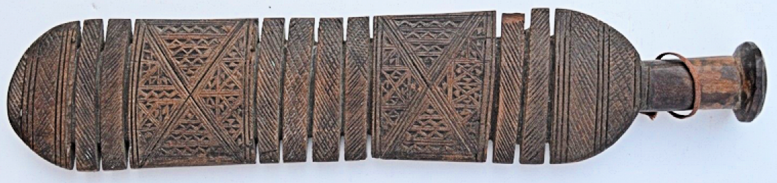

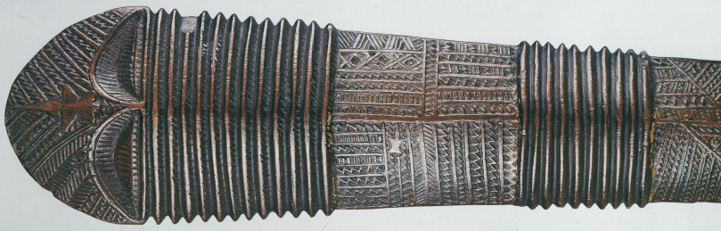

Figs. 1-3. A000-Pac-Poly-Tonga-‘Eua Island-Apai Club, Koa Wood-ca 1780.

**Case No.: 13**

**Accession No.**

**Formal Label:** Pac-Poly-Tonga-‘Eua Island-Apai Club, Koa Wood-ca 1780.

**Display Description:** Short handle style, less than 100 cm. 53.02 cm. Figs. 2-3. Tongan Chief’s Apa’ Apai Club.



Long handle style. More than 100 cm. Length 122 cm. From Cartmail 1997: 130, Fig. 87, 88.

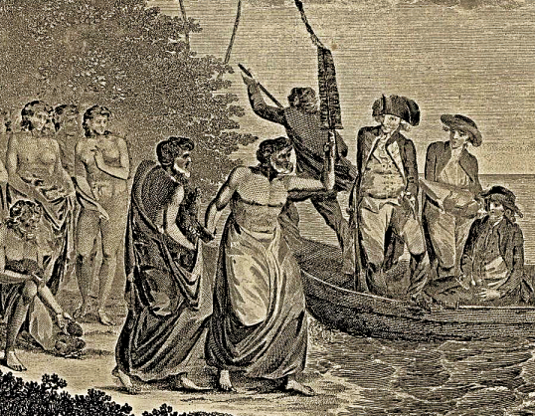



Fig. 4. Detail of “The Landing of Captn. Cook &c. at Middleburgh [‘Eua], one of the Friendly Isles [Tonga],” from the *Journals of Captain Cook* (London: 1780).

This unique 1770’s Tongan Chief’s Apa’Apai Club (determined by the its length under 100 cm vs. those above 100 cm, see Figs. 2-3) was deemed important enough to signify the *ali‘i* standing of the chief and his retinue [which is illustrated in our example] when he brandished it as proof of his chief’s status to Captain James Cook. The artist John Webber included a portrait of himself with his sketchbook in its leather brief case to the far right in the skiff. Webber drew the original sketch of this scene. When Captain Cook arrived in 1774 he was greeted by the local chief as pictured above who greeted him with his Apa’Apai Club of the short version that predates the versions the exceeded 100 cm in length as illustrated in Figs. 2-3. as these were passed down the line of succeeding chiefs. ’Eua was reached by the Dutch explorer Abel Tasman on 21 January 1643 and called it *Middelburg Island*, Dutch capital of Zeeland. While he did not go on land he acquired some artifacts like this pre-19th cent. Apa’Apai Club under 100 cm in length, but these have not been recovered according to Adrienne Kaeppler (1978). Tasman proceeded to the Hihifo district of Tongatapu, which he named *Amsterdam Island* after the capital of the Netherlands. Thereby signifying that the purpose of his voyage was clearly colonialist and not ethnographic in intention

**Case Number:** 13

**Formal Label:** Tongan Chief’s Apa’ Apai Club, koa wood, ca. 1770’s.

**Accession Number:**

**LC Classification:**

**Date or Time Horizon:**

**Geographical Area:**

**Date or Time Horizon:** ca 1780

**Geographical Area:** ‘Eua, Tonga, SE of Tongatapu Island (the largest island in the archipelago).

**Map, GPS: -21.36320 -174.92972;** 40° 26' 46" N 79° 58' 56" W

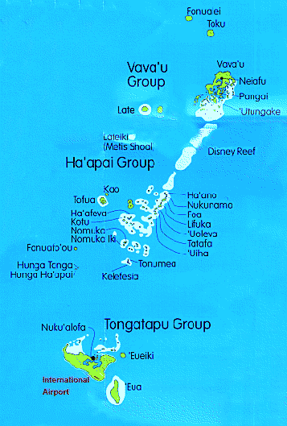

Figs. 5-6. Maps of the Tonga Island archipelago. After <http://www.mapsharing.org/MS-maps/map-pages-state-map/images-state-map/204-tonga-map.jpg> and http://www.baechler.cx/dxpeditions/pacific98/images/tonga.gif

**Cultural Affiliation:** Tongan, Polynesian

**Medium:** Koa wood

**Dimensions:** L 20.875 in/ 53.02 cm; W 4.25 in/ 10.16 cm

**Weight:**

**Provenance:** Ex Donald Stanley Marshall

**Condition:** original

**Discussion:** Tongan Chief’s Apa’Apai Club dating to the 1770’s were important official emblems of the chief’s office when greeting visitors. In the Tongan archipelago there were at least 30 inhabited islands but ‘Eua and Tongatapu were the largest in the south and Vava‘u was the largest in the north so they held sway over adjacent islets.

**References:**

Cartmail, Keith St. 1997. The art of Tonga = Ko e ngaahi'aati'o Tonga. Sydney : G+B Arts International : Craftsman House [distributor],

Kaeppler, Adrienne. 1978**.** "Artificial curiosities”: being an exposition of native manufactures collected on the three Pacific voyages of Captain James Cook at the Bernice Pauahi Bishop Museum, January 18, 1978 - August 31, 1978 on the occasion of the bicentennial of the European Discovery of the Hawaiian Islands by Captain Cook - January 18, 1778. Honolulu, Hawaii Bishop Museum Press.

Oliver, Douglas L. 1975. *Ancient Tahitian Society*: Volume 1, *Ethnography*; Volume 2, *Social Relations*; Volume 3, *The Rise of the Pomares*. Honolulu: University of Hawaii Press.

**Appendix:** additional views.

